Week 1:
Technology
Eat Breakfast
Key vocab:
Metabolism = chemical reaction in the cells that change food to energy
Conserve = to save
Fast = a period of time where you don’t eat or drink
Dietician = an expert on diet and nutrition
-----------------------------------------
Reading:
Is it difficult for you to remember things for a test? Do you feel tired a lot of the time? Try eating breakfast!
The clue for why breakfast is supposed to be the most important meal of the day is in its name: we’re advised to eat it to break our overnight fast.
“The body uses a lot of energy stores for growth and repair through the night,” explains dietician Sarah Elder. “Eating a balanced breakfast helps to up our energy, as well as protein and calcium used throughout the night.”
Probably the most appealing benefit is that breakfast jumpstarts your metabolism and, thus, helps you burn more calories throughout the day.
When you eat breakfast, you're telling your body that there are plenty of calories to be had for the day. When you skip breakfast, the message your body gets is that it needs to conserve, rather than burn, any incoming calories.
According to research, eating a good breakfast can improve memory, concentration, and test marks, especially in maths and reading. But improving schoolwork isn’t the only benefit. Breakfast eaters usually eat more fruit, drink more milk, and eat a larger variety of food than non-breakfast eaters. Because of this research, many schools around the world give students breakfast. Everyone benefits from this: teachers see a reduction in classroom disturbances, and students arrive at school on time and go to more lessons.
So tomorrow morning, take five minutes to eat breakfast before you leave the house. Eggs, cheese, milk, fruit, and muesli are all good things to eat. (Leave the crisps and biscuits in the cupboard!) Your body, your mind – and your teacher – will thank you!

Questions:
Remember to answer in full sentences.
- Throughout the night, what does the body use its energy store for?
________________________________________________________________________________________________________________________________________

- What are three ways breakfast can help you at school?
Breakfast improves ______________________, _____________________________ and _____________________.

- What are three good habits that breakfast eaters usually have?
They usually eat more _________________________, drink more
_______________________ and eat a larger variety of _________________________.

- What are three things teachers notice when students eat breakfast?
Teachers notice a reduction in classroom _____________________, students arrive
at school _______________________and go to more ________________________.

- Each sentence contains a correct and incorrect statement. Cross out the incorrect statement to make the sentence factual.

Non-breakfast eaters eat more/eat less fruit than breakfast eaters.

A healthy breakfast can make you tired/can give you energy.

Teachers see less/more classroom disturbances when students eat school breakfasts.

Students arrive early/late when the school gives breakfast.

Week 2

Drama

The evacuation of children during the Second World War.

Key vocab:
Evacuation= removing to a safer place
Reception = the places that received evacuees
Rural = in the countryside
----------------------------------------
Reading:

With the start of the Second World War came ‘Operation Pied Piper’. The plan was to evacuate civilians from cities and other areas that were at high risk of being bombed or becoming a battlefield in the event of an invasion. The country was split into three types of areas: evacuation, neutral and reception, with the first evacuation areas including places like Greater London, Birmingham, and Glasgow, and reception areas being rural such as Kent, East Anglia and Wales. Neutral areas were places that would neither send nor receive evacuees. Evacuees themselves were split into four categories, focused on specific social groups regarded as non-essential to war work: 1) school-age children; 2) the infirm (unwell or weak); 3) pregnant women, and 4) mothers with babies or pre-school children (who would be evacuated together).
The Government Evacuation Scheme had been developed during the summer of 1938 by the so-called Anderson Committee, chaired by Sir John Anderson and charged with looking at how the country could respond to continued, destructive bombing. The report laid out the foundations of a wartime evacuation policy, recommending the evacuation of schoolchildren, mothers with infants and the elderly to safer locations - typically rural communities.
On the morning of 31 August 1939 (three days before war broke out), an evacuation order was given for the next day. Children began frantically assembling in their schools early on the morning of 1 September and Operation Pied Piper began in earnest. It was an epic challenge requiring thousands of volunteer helpers. London alone had 1,589 assembly points and although most children boarded evacuation trains at their local stations, trains ran out of the capital’s main stations every nine minutes for nine hours. Some children in London were even evacuated by ship from the River Thames, sailing to ports such as Great Yarmouth, Felixstowe, and Lowestoft. The process involved teachers, local authority officials, railway staff and 17,000 members of the Women’s Voluntary Service (WVS), who provided practical assistance, looking after worried and tired evacuees at stations and providing refreshments.
Evacuation day was inevitably a deeply emotional, and often traumatic, experience for all involved and full of uncertainty and tearful goodbyes. Although some children were excited at the prospect of the forthcoming ‘adventure’, most evacuees were unaware of where they were going, what they would be doing, and when they would be coming back. Faced with enormous upheaval and continued separation from loved ones, the initial separation was devastating and heart-rending for both mothers and children as whole families were dislocated and uprooted. However, the fear of bombing attacks meant that most parents considered evacuation for the best, as children would be safer away from the city. Yet, evacuation was not compulsory and some parents were understandably reluctant to take part, despite propaganda posters which encouraged co-operation. For those parents who did co-operate it would be a nervous wait of several days to find out where their children had gone with notification coming via a postcard through the mail.
It was one thing to remove children from at-risk areas, but it was another to find somewhere for them to go. It became compulsory for homes to host assigned evacuees, with host families being paid 10 shillings and sixpence (53p; equivalent to £26 today) for the first unaccompanied child, and 8 shillings and sixpence for any subsequent children. Places were assessed in terms of accommodation available rather than suitability or the hosts’ inclination for raising children. This could lead to resentment of those who would be forced to care for children against their will, made worse by the fact that many children did not want to be there in the first place and tried to run away. This problem was particularly widespread in the lower-class families, as wealthier families often had relatives or school friends in the country to take in their children, rather than relying on strangers.
Questions:
Remember to answer in full sentences.
- What was operation Pied Piper?
____________________________________________________________________________________________________________________________________________________________________________________________________________

- What 4 categories were evacuees split into?
a._______________________________________________________________
b._______________________________________________________________
c._______________________________________________________________
d._______________________________________________________________

- What types of places were evacuated people typically sent to?
____________________________________________________________________________________________________________________________________________________________________________________________________________

- When was the evacuation order given?
________________________________________________________________________________________________________________________________________

- How much were host families paid for evacuees that they agreed to take in?
____________________________________________________________________________________________________________________________________________________________________________________________________________

Week 3:
Media and Film Studies
Impossible?
In both Media and Film Studies (which are GCSE subjects at RBHS) we learn about the film industry. This article discusses the age of actors and the use of CGI (computer generated imagery).
Key vocab:
Immortal = can’t be killed
Galactic = to do with the solar system (space)
Octogenarian = someone who is aged between 80 and 89 years old
Preposterous = ridiculous

Reading:
Anyone remember those strange days, way back in the distant pre-Covid era, when the death of cinema seemed to be imminent and even Tom Cruise couldn’t sell out cinemas? Yet, these days he is regarded as the solution rather than the problem.

Ever since the $1 billion success of Top Gun: Maverick last year, our toothy-grinned hero has been billed as the saviour of cinema. That means we’re probably going to get at least another two decades of Cruise jumping off giant buildings, romancing far-younger women, and generally behaving as if he’s an immortal, all-powerful being from the galactic federation of Xenu until well into his 80s.

Don’t believe me? This week Cruise told the Sydney Morning Herald he is planning to copy Harrison Ford, who is currently starring as a swashbuckling octogenarian archaeologist in ‘Indiana Jones and the Dial of Destiny’.

“Harrison Ford is a legend, I hope to be still going, I’ve got 20 years to catch up with him,” he said. “I hope to keep making Mission: Impossible films until I’m his age.”

How is this going to work? The thing about Ford is that he looks like exactly what he is, an extremely strong and healthy 80-year-old. But you get the impression this isn’t going to be enough for Cruise. Given he looks like a really fit (if slightly greying) 40-year-old in his early 60s, it seems certain that our Tom won’t be content with anything less than resembling a monstrously masculine fifty something by the time Mission: Impossible 20 rolls around in 2042. Perhaps Botox and ice chambers are the answer, or maybe it’s time for Cruise to accept that he needs the retro-ageing tech that allowed Ford to appear as the younger Indy in Dial of Destiny … throughout the whole movie.
At some point though, in this hypothetical scenario, it’s going to become obvious that movie Cruise no longer looks like actual Cruise. The mask of reality will slip, and everyone will realise that they’ve been watching a fake feed of the actor shaking hands with the public for two hours at a premiere in Leicester Square.
Then again, maybe we’re there already. He can’t really ride a motorcycle off a giant ramp and skydive down to a train in his 80s, can he? Wouldn’t it really have been a whole lot easier to just CGI the whole thing? Or – heaven forbid! – morph the star’s face on to a stuntman’s body in the editing room?
‘Mission: Impossible – Dead Reckoning Part One’ is all about Cruise taking on a terrifyingly powerful AI and (we have to assume) winning, even though everyone knows that’s about as likely as Wes Anderson making a Lord of the Rings movie. But if he really does want to carry on making these films into his 80s – doing all his own stunts, saving Hollywood from the threat of Netflix and TikTok – we have to assume that sooner or later he might need more than a helping hand from the wicked digital enemy. After all, there’s impossible and then there’s downright preposterous.

Questions:

Remember to answer in full sentences.

- Identify two things that often happen in Tom Cruise’s films.
- __________________________________________________________________
- __________________________________________________________________

- Who else is making action films at an old age?
________________________________________________________________________________________________________________________________________

- Identify one alternative to Tom Cruise actually doing all of his own stunts.
________________________________________________________________________________________________________________________________________

- Do you think that this article is totally serious or a bit tongue in cheek (jokey)? Find an example in the text that justifies your choice.
____________________________________________________________________________________________________________________________________________________________________________________________________________________________________________________________________________________________________________________________________________________________________________________________________________________________________________________________________________________________

Week 4:

Spanish

Discovering the Culture of Peru

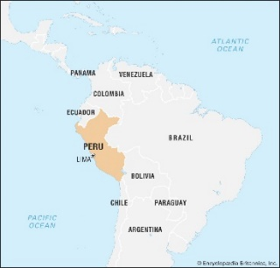
Key vocab:

Diverse = showing a lot of variety

Glimpse = to see something quickly or briefly

Indigenous = native; originally from there

---------------------------------------------
Reading:
Peru, a country in South America, is known for its rich history, diverse landscapes, and vibrant culture. From ancient ruins to colourful festivals, Peru offers a fascinating glimpse into a world where the past and present come together. Let's explore some of the unique aspects of Peruvian culture!

Ancient History

Peru is home to one of the most famous ancient civilizations, the Incas. The Incas built many impressive structures, including the famous Machu Picchu, a city high in the Andes Mountains. This ancient site is one of the most visited places in the world and showcases the incredible architectural skills of the Incas.

Music and Dance
Music and dance are important parts of Peruvian culture. Traditional music often includes instruments like the flute and the panpipe. One popular dance is the Marinera, which is known for its graceful movements and colourful costumes. Another traditional dance is the Huayno, which combines upbeat music with energetic dancing.

Food
Peruvian cuisine is delicious and varied. Some popular dishes include:
- Ceviche: Raw fish marinated in lime juice, mixed with onions, and chili peppers.
- Lomo Saltado: A stir-fry of beef, tomatoes, onions, and fries, often served with rice.
- Papas a la Huancaína: Sliced potatoes covered in a spicy cheese sauce.

Festivals
Peruvians love to celebrate, and their festivals are full of colour and music. One of the most famous is Inti Raymi, or the Festival of the Sun, which celebrates the winter solstice. Another important festival is Fiestas Patrias, celebrating Peru's independence with parades, fireworks, and traditional music.

Language

The official language of Peru is Spanish, but many Peruvians also speak indigenous languages like Quechua and Aymara. Learning these languages helps keep the rich cultural heritage of the country alive.

Questions:

Remember to answer in full sentences.

- Which ancient civilization is Peru known for?
________________________________________________________________________________________________________________________________________

- What is Machu Picchu, and where is it located?
________________________________________________________________________________________________________________________________________________________________________________________________________________________________________________________________________________

- Name two traditional dances mentioned in the text.
- _______________________________________________________________
- _______________________________________________________________

- List three popular Peruvian dishes described in the text.
- _______________________________________________________________
- _______________________________________________________________
- _______________________________________________________________

- Which three languages are spoken in Peru?
  - _________________________________________________________
  - _________________________________________________________
  - _________________________________________________________

Week 5:
Religious Studies
Why is the Lord’s Prayer important to Christians?

Key vocab:
Hallowed = holy
Temptation = the desire to do something wrong or unwise
Virtue = being morally good
---------------------------------------------
Reading:

We have been studying the beliefs of Christianity. This article explains the importance of the prayer as a form of communication with God.

Article: What is the Importance of the Lord’s Prayer taken from Learn Religions?
The Lord's Prayer is a more common name for the ‘Our Father’: the prayer that Christ taught to his disciples when they asked him how to pray (Luke 11:1-4). The name "The Lord's Prayer" is used most often today by Protestants.

Our Father, who art in Heaven,
hallowed be thy name;
thy kingdom come;
thy will be done
on earth as it is in Heaven.
Give us this day our daily bread.
And forgive us our trespasses,
as we forgive those who trespass against us.
And lead us not into temptation;
but deliver us from evil.
For thine is the kingdom,
the power and the glory,
for ever and ever.
Amen.

The best way to understand the Lord's Prayer is to break it down line by line.
‘Our Father’ means God is "our" Father, the Father not only of Christ but of all of us. We pray to him as brothers and sisters to Christ, and to one another.
‘Who art in Heaven’: God is in Heaven, but that does not mean that he is distant from us. He is above all of Creation, but he is also present throughout Creation.
‘Hallowed be thy name’: To "hallow" is to make holy; God's Name is "hallowed," holy, above all others. As Christians, we desire that all honour God's name as holy, because acknowledging God's holiness draws us into the right relationship with him.
‘Thy kingdom come’: The kingdom of God is his reign over all mankind. It is not simply the objective fact that God is our king, but also our acknowledgment of his reign. We look forward to the coming of his kingdom at the end of time, but we also work toward it today by living our lives as he wishes us to live them.
‘Thy will be done on earth as it is in Heaven’: We work toward the coming of the kingdom of God by living our lives according to his will. With these words, we ask God to help us know and carry out his will in this life.
‘Give us this day our daily bread’: With these words, we ask God to provide us with everything that we need (rather than want). "Our daily bread" is that which is essential for everyday life. That does not mean simply the food and other goods that keep our physical body alive, but that which nourishes our souls as well.
‘And forgive us our trespasses, as we forgive those who trespass against us’: We have asked him already to help us know his will and to do it; here, we ask him to forgive us our sins—but only after we have forgiven the sins of others against us. We beg God to show us mercy, not because we deserve it but rather because we do not; but we must first show mercy toward others, especially when we think that they do not deserve it.
‘And lead us not into temptation’: A temptation is a trial; in this request we ask God to keep us from entering into trials that test our faith and virtue, and to keep us strong when we must face such trials.
‘But deliver us from evil’: The English translation again hides the full meaning of this final request. The "evil" here is not just bad things; in the Greek, it is "the evil one"—that is, Satan himself, the one who tempts us. We pray first not to enter into Satan's trials, and not to give in when he does tempt us, and then we beg God to deliver us from Satan's grasp.
The Doxology: The words "For thine is the kingdom, the power and the glory, for ever and ever" are not actually part of the Lord's Prayer, but a doxology—a form of praise to God.
Questions:
Remember to answer in full sentences.

What is the Lord’s Prayer a more common name for?
____________________________________________________________________________________________________________________________________________________________________________________________________________

Where- in the bible- does the prayer come from?
____________________________________________________________________________________________________________________________________________________________________________________________________________

What does “Our Father” mean?
________________________________________________________________________________________________________________________________________
____________________________________________________________________

What does “hallowed be thy name” mean?
________________________________________________________________________________________________________________________________________
____________________________________________________________________

What does “thy kingdom come” mean?

____________________________________________________________________________________________________________________________________________________________________________________________________________

What does “give us this day our daily bread” mean?

____________________________________________________________________________________________________________________________________________________________________________________________________________

What does “And lead us not into temptation” mean?
____________________________________________________________________________________________________________________________________________________________________________________________________________

Week 6:
Geography
Geography of the UK
Key vocab:
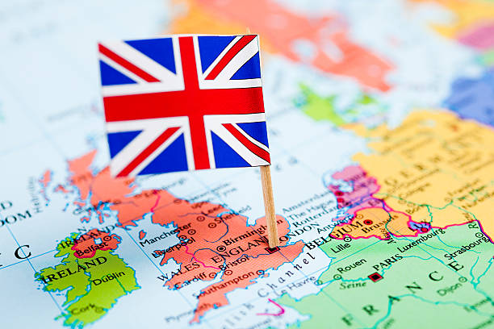
Globalisation = The spread of products across countries.
Urbanisation = The process of making more areas into towns and cities.
Accumulated = increasing numbers
Export = a product sold outside of the country that it is made/ produced in.
-------------------------------------
Reading:
This half term, you will begin to study the Geography of the UK, studying the local area, physical features, human features and processes such as globalisation and urbanisation.
The biggest part of the United Kingdom (also called the U.K.) is the island of Great Britain, which is made up of England, Wales, and Scotland. The U.K. also includes Northern Ireland, which is on another island. (South of Northern Ireland is the separate country of Ireland, which gained its independence from the U.K. in 1937.) Northern Ireland is just 12 miles from the island of Great Britain, across the North Channel of the Irish Sea.
Scotland and Wales are the most mountainous parts of the U.K. and are covered in knife-edged mountain ridges separated by deep valleys. This terrain was shaped some 20,000 years ago during the last Ice Age, when thick glaciers covered the land. When the Ice Age glaciers melted in northwest Scotland, they left behind thousands of lakes, called lochs (pronounced LOCKS). Long and narrow, some of the lochs are very deep…

NATURE
About 5,000 years ago, much of the United Kingdom was covered with thick forests. Over time, these woodlands were cleared by farmers and land developers—today, only about 13% of the U.K.’s land is forest.
The United Kingdom is a crowded country, with few truly wild places left. The most successful wildlife species are those that can live alongside people, including smaller mammals like hedgehogs, hares, and badgers. Roe deer, which are native to the country, and red deer are the largest mammals found in the U.K.
The Scottish Highlands, which are largely untouched by humans, are home to animals like the Scottish wild cat, pine martens, and golden eagles. Lough Neagh in Northern Ireland is home to some 20 species of waterfowl, including ducks, gulls, geese, and swans.
GOVERNMENT AND ECONOMY
The U.K.’s system of government has developed over many centuries. As early as the ninth century, kings and queens ruled with advice from a council of religious leaders and nobles.
Today, the country is a constitutional monarchy, which means the reigning king or queen is the head of state, but doesn’t have any real political power.
The old council of advisers eventually expanded into a government body called Parliament. That’s why today, the United Kingdom’s system of governing is called a parliamentary democracy.
Members of Parliament now pass all the country's laws from two chambers: the House of Commons, made up of officials elected by the people, and the House of Lords, in which members are appointed, usually by the reigning king or queen based on recommendations by an independent group called the House of Lords Appointments Commission.
The head of the government is the prime minister, who is usually the leader of the political party in charge of Parliament.
Oil, iron, and steel products are some of the United Kingdom’s main exports, or goods sold to other countries. The country also exports electrical equipment, and parts for automobiles and aircrafts. Its main crops produced include barley, wheat, and potatoes.
Over the centuries, the United Kingdom has accumulated wealth from foreign lands the country colonised or took control over. Some estimates say the U.K. earned more than $45 trillion in today’s dollars just from its former colony of India, when trade from goods that India produced went to the U.K’s economy. Other former colonies include Australia, Canada, and South Africa.
Questions:
Remember to answer in full sentences.

- What is the difference between the United Kingdom and Great Britain?
____________________________________________________________________________________________________________________________________________________________________________________________________________

- What period shaped the mountains in Wales and Scotland?
____________________________________________________________________________________________________________________________________________________________________________________________________________

- What percentage of the UK is currently forest?
________________________________________________________________________________________________________________________________________

- What is a constitutional monarchy?
____________________________________________________________________________________________________________________________________________________________________________________________________________

- What is the UK’s system of governing?
________________________________________________________________________________________________________________________________________

- What are the UK’s main exports?
________________________________________________________________________________________________________________________________________

- How much money has the UK earned from India?
________________________________________________________________________________________________________________________________________

Week 7:
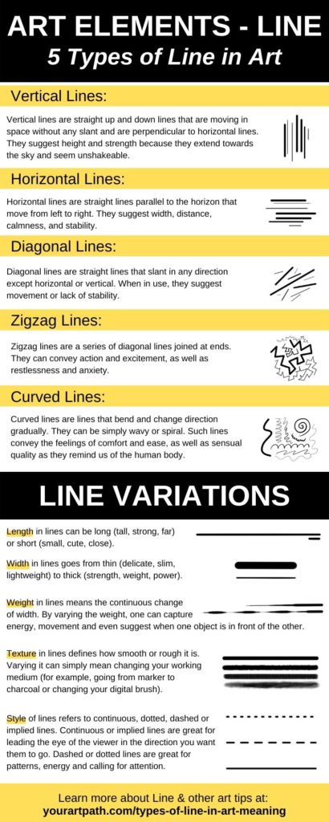
Art
Formal Elements of Art
Key vocab:
Infinite = never ending
Denote = to indicate
Invokes = causes/brings on
Gestural = relating to movement, or a forceful application of paint
-------------------------
Reading:
Within Art there are 8 formal elements: line, tone, texture, pattern, colour, shape, space and 3D. Below, you will read a brief description of each element which will allow you to develop your understanding of the basic elements in Art.

Line
A line can be an infinitely long object that is one-dimensional. The word line may also refer to a line segment in everyday life that has two points to denote its end. Line is described as the path left by a point moving from a to b.
A line can take many forms: horizontal, diagonal, vertical, zigzag, or curved. Lines can be thick, thin, dotty, or sketchy and can be created using a variety of mediums- for example, a pencil or a brush dipped in paint.

Tone
In Art and Design, tone refers to how light or dark something is. Tone refers to black, white and the grey tones in-between, as well as how light or dark a colour appears. Tone ranges from pure white to total black and everything in between. Each colour can have an almost infinite range of tones.
When light falls on a three-dimensional object, tones are created. The face - or sides - that light hits directly will be the brightest. The bright areas are called highlights. Objects block light, so the face away from the light source will be in darkness. The dark area is called shadow.
Light and dark tones can create the illusion of form and therefore, realistic pieces of Art. Progressive tones can create depth and it's the range and contrast of tones used that will give an art composition its atmosphere.
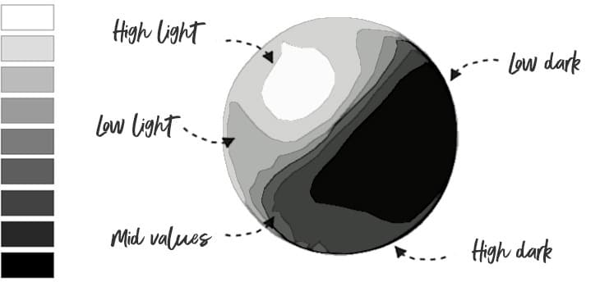

Texture
Texture refers to how something feels, including its appearance and consistency. Glass, wood, rock and sand all have different textures, while words that we use to describe texture include rough, smooth, soft, and glossy.
Texture in Art concerns the surface quality of a piece of work. In three-dimensional artwork, the term refers to how the piece feels when it’s touched. In paintings and other two-dimensional artwork, texture invokes the visual ‘feeling’ the piece creates.
Artists and designers can influence the surface quality of a piece of work, using real materials or techniques that imply different textures. Texture is one of the formal elements of art, making it a fundamental element of every artist’s work.
Mark making describes the different lines, dots, marks, patterns, and textures we create in artwork. It can be loose and gestural or controlled and neat. It can apply to any material used on any surface: paint on canvas, ink or pencil on paper, a scratched mark on plaster, a digital paint tool on a screen, a tattooed mark on skin.
Questions:
Remember to answer in full sentences.
- Name 5 different types of line.
- __________________________________________________________
- __________________________________________________________
- __________________________________________________________
- __________________________________________________________
- __________________________________________________________

- What is meant by tone in Art?
________________________________________________________________________________________________________________________________________________________________________________________________________________________________________________________________________________

- Describe how light affects a shape to make it have tone.
________________________________________________________________________________________________________________________________________________________________________________________________________________________________________________________________________________________________________________________________________________________________________________________________________________________

- How might you describe texture?
____________________________________________________________________________________________________________________________________________________________________________________________________________

- What is mark making?
________________________________________________________________________________________________________________________________________________________________________________________________________________________________________________________________________________
____________________________________________________________________

Week 8:
Computer Science
Starring in your very own blockbuster movie with your favourite celebrity.
Ethical and Legal Issues of Computing and Technology

Key vocab:
Deepfake = A type of artificial intelligence (AI) used to create convincing images, audio and video hoaxes of real people, dead or alive.
Consent = permission
Controversial = likely to causing conflict or disagreement
Avatar = A computer representation of users in a computer-generated 3D world.
-----------------------------
Reading:
Advances in deepfake technology raise the idea that the day will soon come when the digital likeness of actors can be brought to life for movies and TV without their needing to even lift a finger. Deepfakes can be used to create realistic videos - often of celebrities or politicians. For actors that can no longer act, the technology has the potential to be game-changing.
However, the issue is that performers are having their image, voice, or likeness reproduced by others, using AI technology, without their consent. The Daily Mail newspaper reported that a deal had been struck between Bruce Willis and a deepfake company called Deepcake.
"Bruce Willis has become the first Hollywood star to sell his rights to allow a 'digital twin' of himself to be created for use on screen." said the Telegraph.
But that doesn't appear to be the case. According to a representative of Bruce Willis he did not sell his likeness to Deepcake. What is true is that a deepfake of Bruce Willis was used to create an advert for Megafon, a Russian telecoms company, last year.
AI replacement [deepfakes] appears to be a growing trend. Darth Vader actor James Earl Jones has recently retired from playing the famous character, but his voice has carried on. Respeecher, another AI firm, has reportedly used archival materials to copy the Vader vocals using a computer aided AI algorithm.
Disney released its Star Wars spinoff, Obi-Wan Kenobi which uses Respeecher's technology to reproduce Vader's speech and even make him sound younger.
AI replacement, however, is controversial. There are no UK laws explicitly written to regulate AI. This includes the Copyright, Designs and Patents Act 1988, which provides the legal framework for performers’ intellectual property.
The gaming industry is another natural arena for disruption by deepfakes, particularly with respect to avatars. A key principle of many games is a player assuming the role of a character, such as Luke Skywalker or Princess Leia from Star Wars. But an even more immersive gaming experience would be not simply controlling Luke or Leia with a gamepad, but also having the avatar track your face and mouth movements—something deepfake technology is making a reality. Further, with deepfake-generated synthetic speech, it is possible to make your voice sound like Luke or Leia, and this has sometimes resulted in unanticipated positive consequences.
Now imagine… coming home from school and asking your new AI streaming platform ‘Hey, I want a movie starring my avatar and Chris Hemsworth’s avatar. I want it to be a new Avengers movie based upon comic issue #123’ In theory, using deepfakes, the AI could create a good quality story with dialogue that copies your likeness and voice, and suddenly now you have an action packed Marvel movie starring you that’s 90 minutes long.
Questions:
Remember to answer in full sentences.
- What is a deepfake?
____________________________________________________________________________________________________________________________________________________________________________________________________________

- What is one issue created by the invention of deepfakes?
____________________________________________________________________________________________________________________________________________________________________________________________________________

- Did Bruce Willis consent to his image [likeness] being used as a deepfake? What really happened?
________________________________________________________________________________________________________________________________________________________________________________________________________________________________________________________________________________________________________________________________________________________________________________________________________________________

- There are no current laws that protect us against the use of deepfakes. According to the text, state the name of the law that protects performers’ intellectual property.
____________________________________________________________________________________________________________________________________________________________________________________________________________

- What is a possible positive of deepfakes, for regular people?
________________________________________________________________________________________________________________________________________________________________________________________________________________________________________________________________________________

Week 5:
PE
A Belgian shot-putter hops over hurdles after answering her team's call for help
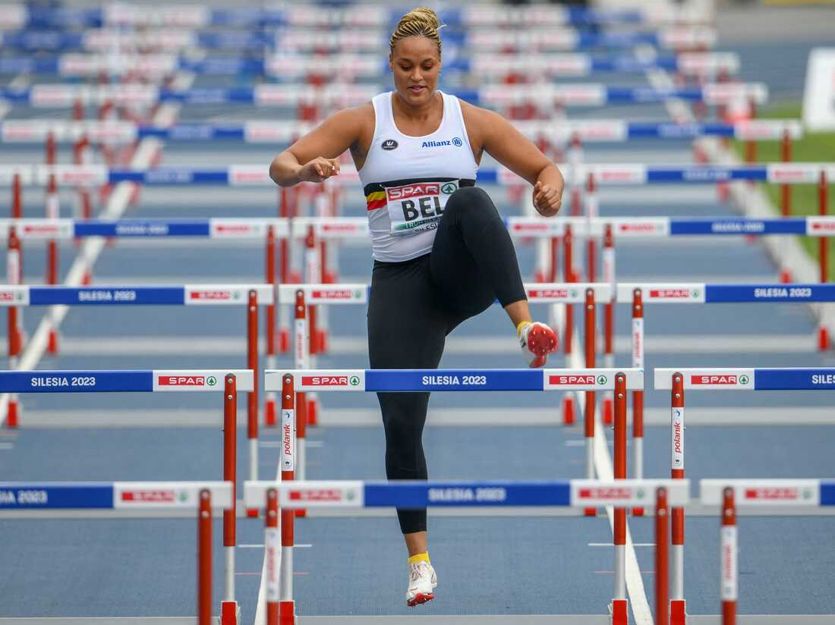
Key vocab:
Gamely = in an enthusiastic way
--------------------------------
Reading:
When a top Belgian hurdler couldn't race in the European Athletics Team Championships, her team turned to its top shot-putter. So Jolien Boumkwo gamely ran the women's 100 meters hurdles, delivering two points for her team. She did it all with a smile.
She was called to duty on Saturday after Anne Zagré, the Belgian national record-holder in the 100-meter hurdles, was forced out with an injury. The country's Hanne Claes was also out. And with a Swiss hurdler disqualified in Heat A, it was up to Boumkwo to seize two points for Belgium.
"My team is the most important thing for me," Boumkwo told Agence France-Presse, adding, "I couldn't let it happen to lose by one point."
Boumkwo said she immediately said yes when her team asked whether she could possibly run hurdles, and her coach agreed — as long as she did it carefully. After all, as Boumkwo told Belgian public broadcaster Sporza, they sometimes include hurdles in her training.
Boumkwo waved as she was introduced, taking her spot in the blocks. There was no question of where she would finish. Although the shot-putter got through the race cleanly, her rivals were already facing their third set of hurdles as she got over her first obstacle.
At the finish line, Boumkwo's fellow racers greeted her with high-fives and handshakes. She set a season-best time of 32.81.Her national team thanked her for her sacrifice, saying it was part of athletics — and that's why we love it so much! “If her two points might help Belgium stay in the top division”, Boumkwo told Sporza, “it would be worth it.”

Questions:
Remember to answer in full sentences.
- Jolien Boumkwo is her country’s top performer in which sport?
________________________________________________________________________________________________________________________________________

- How many points did Boumkwo receive for taking part in the event?
________________________________________________________________________________________________________________________________________

- Why did the Belgian record-holder for hurdles not compete in the Hurdles event?
____________________________________________________________________________________________________________________________________________________________________________________________________________

- How was Boumkwo received at the finish line by her fellow competitors?
____________________________________________________________________________________________________________________________________________________________________________________________________________

- In your opinion, what does this story teach us about teamwork?
________________________________________________________________________________________________________________________________________________________________________________________________________________________________________________________________________________________________________________________________________________________________________________________________________________________

Week 9:
History- What was the greatest impact of the Romans on Britain?
We have been studying the settlers who came to Britain and changed the landscape of the country for years to come. As you read, consider the key question above by thinking about the impact on the Romans on Britain.
Key Vocab:
Brutality = violent and aggressive in nature
Conquest = taking over something
Auxiliary = Supporting/ back up
Isthmus = a narrow strip of land bordered by water on both sides, connecting two larger land masses.

Reading:
Article: An introduction to Roman Britain, taken from the English Heritage website.
To the Roman world, Britain was an unknown and mysterious land across the sea when Julius Caesar invaded in 55–54 BC. Despite inflicting defeats on the British, Caesar soon made peace with his opponents and returned to Europe. For almost a century afterwards the kingdoms of Britain were kept quiet with gifts and diplomacy. But when anti-Roman rulers came to power, the emperor Claudius – in need of a boost to his domestic (home) reputation – launched a full-scale invasión on Britain in AD 43, intent on regime change and military glory.

INVASION AND CONQUEST

This time the Romans enjoyed rapid military success. But gradual advance through southern England and Wales was stopped in AD 60 by the rebellion of Boudicca, queen of the Iceni of East Anglia, angered by the brutality of the conquest. The revolt was suppressed, but not before three recently founded Roman cities, Camulodunum (Colchester), Verulamium (St Albans) and Londinium (London), had been burned to the ground.

The advance resumed in AD 70 with the conquest of Wales and the north. The governor Agricola (AD 77–83) even succeeded in defeating the Scottish tribes at the Battle of Mons Graupius in AD 83. Immediately after this victory, though, troops were pulled out of Britain to deal with invasions in modern day Germany. As a result, the far north could not be held, and the army gradually fell back to the Tyne–Solway isthmus. It was here that the emperor Hadrian, visiting Britain in AD 122, ordered the building of his famous wall.

ROMAN ORDER

By now the three legions (army units of up to 6,000 men) remaining in Britain had settled in permanent bases. Auxiliary troops were scattered in smaller forts, mostly across northern England and along Hadrian’s Wall. In the peaceful parts of Britain, cities had been founded as capitals for each of the tribal areas (the civitates), a network of roads had developed, and landowners in the south began to build Roman-style villas. Life, for most ordinary Britons, who were farmers in the countryside, was slow to change. By degrees, however, they came into contact with villas, towns and markets. Here they could exchange their produce for Roman-style goods and see people dressing and behaving in Roman ways.

DIVISION OF BRITAIN
Shortly after AD 180 there was an invasion by tribes from what is now Scotland, who overran Hadrian’s Wall. Around this time most of the cities of Britain were enclosed within earthen defensive walls, which may have been linked to the invasion. The Roman Empire was ruled from Britain for a brief period in AD 208–11, when the emperor Septimius Severus came to campaign north of Hadrian’s Wall. Severus divided Britain into two provinces, Britannia Superior (south) and Inferior (north), with capitals at London and York respectively. This prevented too many troops from being concentrated in the hands of a single governor who might have attempted to usurp power.

Questions

- Why did the Romans decide to invade Britain in AD 43?
______________________________________________________________________________________________________________________________________________________________________________________________________

- What problems did Boudicca cause for the Romans?
______________________________________________________________________________________________________________________________________________________________________________________________________

- What positives did the Romans bring to Britain?
______________________________________________________________________________________________________________________________________________________________________________________________________

- What problems did the Scottish cause for the Romans?
______________________________________________________________________________________________________________________________________________________________________________________________________

- How did leader Septimius Severus divide Britain after AD 208-11?
________________________________________________________________________________________________________________________________________________________________________________________________________________________________________________________________________

Week 6:
Business Studies
The Return of the Furby

Key vocab:
Iconic = legendary/famous
Bulbous = round and swollen looking
Infrared = radiant energy that’s invisible to the human eye but we can feel as heat
Revamped = remade/updated
-------------------------------------------------
Reading:

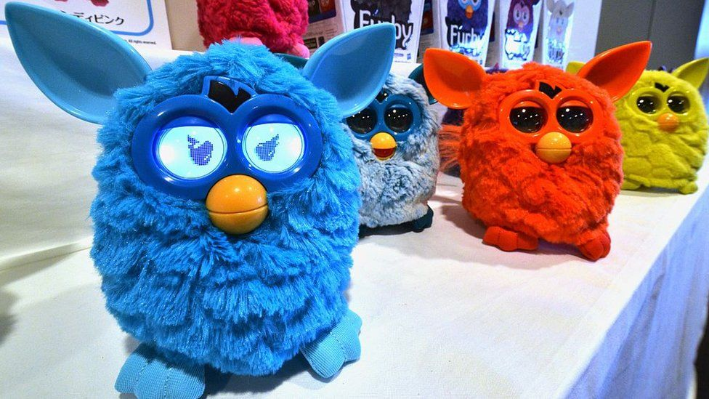
US toy giant Hasbro has brought back the iconic Furby robotic creature, which was hugely popular when it was launched a quarter of a century ago. The firm hopes a new generation of children will "discover their own curious little creature".

The new Furby has its familiar bulbous eyes, yellow beak, and colourful fur. It also speaks in nonsense-language and responds to hugs, pats and tickles.

The announcement comes as the toy industry faces a slowdown in demand.
"Over the past few years, we've done a lot of research to understand what kids would want to see in a new Furby," said Kristin McKay, a vice president and general manager at Hasbro. The new toy is programmed to have more than 600 responses. It can react to commands, copies sounds, dance, and be "fed".

Furby, which was originally launched in 1998, quickly became popular around the world. In the first three years after being launched, more than 40 million of them were sold, Hasbro says. The first Furby had infrared eyes which allowed them to communicate with each other. The toy could also "listen" to conversations, and could, with a pat on the head, be taught to say a selection of words.

Furby has been revamped over the years, including its infrared eyes being replaced with two small LCD screens. Hasbro also developed a smartphone and tablet app, which could translate Furby's warblings into English. However, as the Furby phenomenon faded it was retired in 2016.

Questions:
Remember to answer in full sentences.

- Why is toy giant Hasbro bringing back the iconic Furby robotic creature?
________________________________________________________________________________________________________________________________________________________________________________________________________________________________________________________________________________________________________________________________________________________________________________________________________________________

- What features does the new Furby share with the old Furby?

________________________________________________________________________________________________________________________________________________________________________________________________________________________________________________________________________________

- What issue is the toy industry currently facing?

________________________________________________________________________________________________________________________________________________________________________________________________________________________________________________________________________________

- When was the original Furby launched?

____________________________________________________________________________________________________________________________________________________________________________________________________________

Week 6:
Social Science
Scandinavian Prisons vs. UK Prisons: A Surprising Difference

Key vocab:
Rehabilitation = restoring to health or normal life.
-------------------------------
Reading:
Have you ever wondered what life is like in prison? Well, did you know that Scandinavian prisons are quite different from prisons in the United Kingdom? In Scandinavia, which includes countries like Sweden, Norway, and Denmark, they focus more on helping prisoners change and become better people. Let's explore some interesting facts about Scandinavian prisons and compare them to the ones in the UK.
Helping and Changing
Instead of just punishing people, Scandinavian prisons want to focus on rehabilitation: helping prisoners change their behaviour and become better citizens. They give prisoners chances to learn new things, like going to school or learning new skills. The idea is to get them ready to be successful in society when they are released.
Where They Live
The living conditions in Scandinavian prisons are also different from the ones in the UK. In Scandinavian prisons, the cells are often smaller and more comfortable. Can you believe that some prisoners even get their own keys to their cells? This shows that they trust the prisoners to be responsible. Scandinavian prisons also want prisoners to be respectful and get along with each other, so they encourage them to do activities together. In the UK, prisons usually have bigger cell blocks and stricter rules.
Committing Crimes Again
‘Recidivism’ means the rate at which former prisoners commit crimes again after they are released. Here's something interesting: Scandinavian countries have some of the lowest recidivism rates in the world, which means fewer people go back to prison. This suggests that the way Scandinavian prisons help prisoners change and become better people really works. In the UK, the recidivism rates tend to be higher, which means more people go back to prison. Maybe they can learn something from Scandinavia!

Questions:
Remember to answer in full sentences.

- What is the main goal of Scandinavian prisons?
________________________________________________________________________________________________________________________________________________________________________________________________________________________________________________________________________________

- How do Scandinavian prisons help prisoners get ready to be successful in society?
________________________________________________________________________________________________________________________________________________________________________________________________________________________________________________________________________________

- How are living conditions in Scandinavian prisons different from UK prisons?
________________________________________________________________________________________________________________________________________________________________________________________________________________________________________________________________________________

- What does "recidivism" mean?
________________________________________________________________________________________________________________________________________________________________________________________________________________________________________________________________________________

- Which region has lower recidivism rates: Scandinavia or the UK?
________________________________________________________________________________________________________________________________________

