Week 1:
Social Science
Taylor Swift: Promoting Feminist ideas through music
Key vocab:
Feminist = someone who wants equal rights for women
Empowering = inspiring and making people feel powerful
Resonated = agreed with
Discrimination = treating people unfairly, especially on the grounds of ethnicity, age, sex, or disability
Reading:
In the world of music, there are artists who not only captivate our ears but also inspire us with their beliefs and actions. Taylor Swift is one such artist who has become a feminist icon; empowering girls and breaking barriers. Taylor Swift's journey as a musician and activist has made her a role model for young girls, championing equality and encouraging them to dream big.
Taylor Swift has shattered stereotypes that limit what girls can achieve in the music industry. She has shown that girls can succeed in any genre they choose and has fearlessly experimented with various musical styles throughout her career. By going against expectations and showcasing her talent and versatility, Taylor Swift has paved the way for girls to pursue their passion for music without limitations.
One of the reasons Taylor Swift has resonated so deeply with young girls is her ability to write songs that capture their emotions and experiences. Her lyrics often explore themes of love, heartbreak, friendship, and self-discovery – topics that many teenage girls can relate to. By sharing her own personal stories and vulnerabilities, Taylor Swift encourages girls to embrace their feelings, find their voices, and know that they are not alone in their struggles.
She has also been a vocal advocate for gender equality, using her platform to speak out against sexism and discrimination. She has openly addressed issues such as body positivity and women's rights. By speaking up on these important topics, Taylor Swift encourages girls to stand up for themselves and others, fostering a belief in equal opportunities and fair treatment for everyone, regardless of gender.
Taylor Swift's journey of self-discovery and embracing her true self serves as an inspiration for young girls. Through her music and public persona, she encourages girls to embrace their uniqueness, celebrate their strengths, and be confident in their abilities. Taylor Swift's message of self-acceptance and embracing individuality promotes a positive body image and encourages girls to value themselves for who they are, rather than conforming to societal pressures.
Beyond her music and activism, Taylor Swift has shown a strong commitment to helping others. She has donated generously to causes like education, disaster relief, and fighting poverty. Taylor Swift's charitable efforts remind young girls that they have the power to make a difference, no matter their age or circumstances. She inspires them to use their talents and resources to help those in need and contribute to building a better world.
Taylor Swift's journey from a young country music sensation to a feminist icon has been truly inspiring. Through her music and charitable donations, she has become a role model for young girls, encouraging them to break barriers, embrace their true selves, and stand up for what they believe in. Taylor Swift's empowering messages serve as guiding lights for young girls, reminding them that they have the power to make a difference and create positive change in the world.
Questions:
- How has Taylor Swift broken stereotypes in the music industry?
________________________________________________________________________________________________________________________________________________________________________________________________________________________________________________________________
- What kind of themes does Taylor Swift often explore in her songs that resonate with young girls?
________________________________________________________________________________________________________________________________________________________________________________________________________________________________________________________________
- How has Taylor Swift used her platform to campaign for gender equality?
________________________________________________________________________________________________________________________________________________________________________________________________________________________________________________________________

- How does Taylor Swift inspire confidence and self-acceptance among young girls?
________________________________________________________________________________________________________________________________________________________________________________________________
- Apart from her music and activism, what other ways has Taylor Swift contributed to society?
________________________________________________________________________________________________________________________________________________________________________________________________

Week 2:
Religious Studies
How can the story of Joseph help us to understand Christian responses to suffering in our world?

Key vocab:
Contemplate = think deeply about
Devoured = eaten
Pharaoh = an Egyptian ruler
Overseer = manager
Famine = an extreme shortage of food
Salvation = being saved
--------------------------------------------------
Reading:
We have been studying different ideas of why we suffer as part of our unit on Creation. This article explains an Old Testament story and helps us to further contemplate who is responsible for suffering in our world.

Article: Lessons from the life of Joseph from www.LifeHopeandTruthBlog.org

Joseph was born into a family of 10 older brothers and at least one sister. His father, Jacob, had four wives, but Joseph was the firstborn of Rachel, the true love of Jacob’s life. Sadly, Joseph’s mother died when his younger brother Benjamin was born. Joseph was Jacob’s favourite son. This caused his brothers to envy and dislike him.
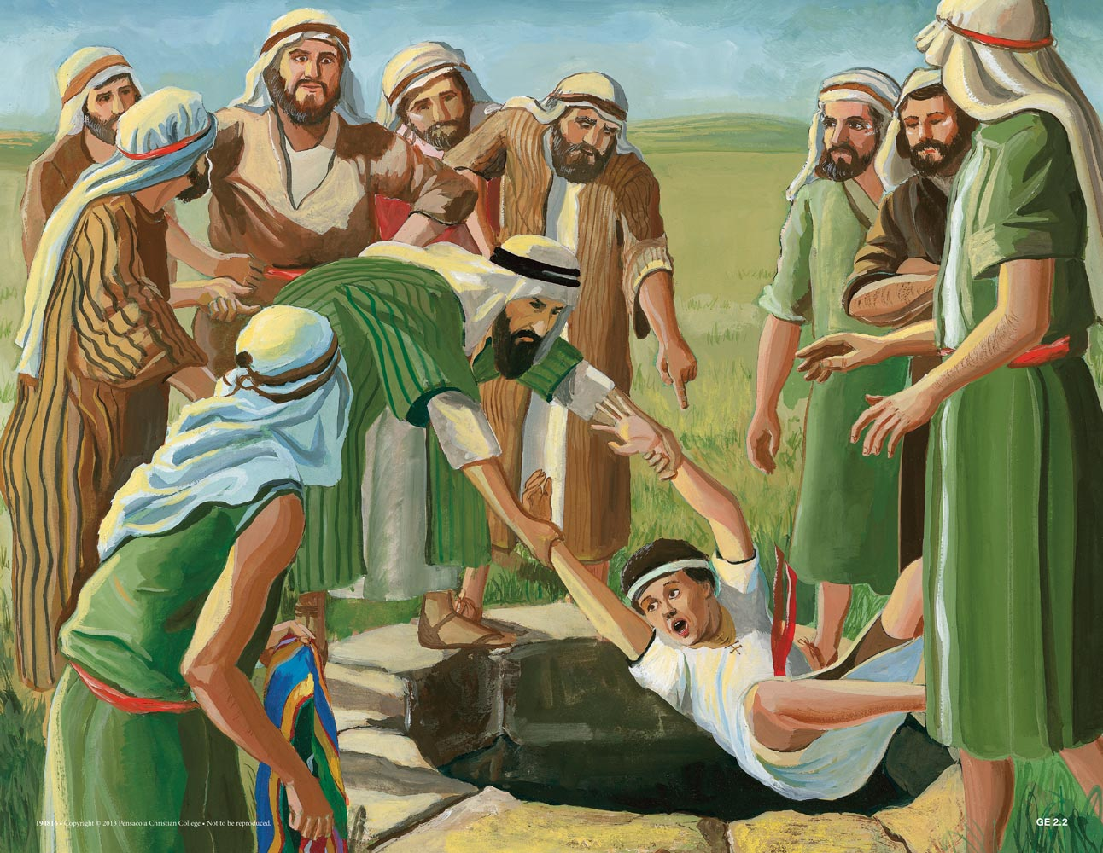
Joseph’s troubles reached a new level when he was 17. After a series of dreams showed that God would raise Joseph over his brothers, his brothers’ dislike for him took a darker turn. They decided to throw him into a pit and leave him for dead. But, as they were eating, a band of Ishmaelite traders passed by, so they decided to sell him into slavery for profit instead. Joseph was then taken to Egypt as a slave. His brothers led their father to believe that a wild animal had attacked and devoured him.
In Egypt, Joseph served Potiphar (the Pharaoh’s guard) well—with hard work, skill and honesty—and God blessed everything he was involved in. Potiphar eventually saw how Joseph’s work was blessed and made him overseer of his entire household. However, things took a turn when Potiphar realised that his wife was attracted to Joseph, so he had him thrown into jail.
During the time Joseph was serving Potiphar, the world was hit by a devastating famine. Joseph’s brothers were forced to go to Egypt to buy grain. While there, they encountered a grown-up Joseph, but had no idea who he was (as they hadn’t seen him in about 20 years.) However, he recognised them. To make a long story short, Joseph eventually put them in prison. There they started to recognise that their troubles resulted from what they had done to Joseph years earlier.
However, through a series of tests, Joseph decided that they had matured beyond who they were when they showed such cruelty to him. Ultimately, Joseph saw that they were willing to sacrifice their lives to save his younger brother Benjamin. Joseph was unable to hold back his emotions any longer and revealed himself to them.
Remember the dreams Joseph had when he was young? The brothers had interpreted the dreams as Joseph ruling and lording it over them. So, they attacked him based on this interpretation. It wasn’t until Joseph revealed himself that they realised the dreams weren’t about lordship, but about salvation and service.
This is one of the most important lessons that we can learn from this story. Many evils are inflicted in this world, but God has set a plan in motion that will turn evil into good: “All things work together for good to those who love God, to those who are the called according to His purpose” (Romans 8:28). Despite everything he went through, Joseph’s suffering turned out for good. He didn’t allow his experiences to lead him away from the way of life he knew was right. We can do the same thing.

Questions:
- Why did Joseph’s brothers envy him (why were they jealous of him)?
__________________________________________________________________________________________________________________________________________________________________________________________

2. What did Joseph’s brothers do to him?
________________________________________________________________________________________________________________________________________________________________________________________________________________________________________________________________
3. In Egypt, what role did Joseph end up taking on?
________________________________________________________________________________________________________________________________________________________________________________________________________________________________________________________________
4. How did Joseph manage to see his brothers again?
________________________________________________________________________________________________________________________________________________________________________________________________________________________________________________________________
5. What did Joseph eventually realise about his brothers?
________________________________________________________________________________________________________________________________________________________________________________________________________________________________________________________________
6. What does Joseph’s story teach Christians about suffering?
________________________________________________________________________________________________________________________________________________________________________________________________

Week 3:

Business Studies

Virgin Galactic commercial space flights to start

Key vocab:
Commercial = for business use (for profit)
Billed = in this context, billed means ‘advertised as’
Debut = the first of its kind
-------------------------------------------------
Reading:

Sir Richard Branson's space tourism company Virgin Galactic says it will launch its first commercial flight before the end of this month.
After this announcement to investors, Virgin Galactic shares increased by more than 40% in extended New York trading.

Virgin Galactic said the first flight would be a scientific research mission, carrying three crew members from the Italian Air Force and the National Research Council of Italy to carry out microgravity research.

The company said its second commercial spaceflight will follow in early August, and it expects to operate monthly spaceflights from then on. It marks a key milestone for the 19-year-old Virgin Galactic, which has had to overcome a series of accidents and technical challenges.

Last month, Virgin Galactic's rocket plane, which is called Unity, was back in action after a gap of almost two years. The vehicle, with two pilots and four passengers aboard, climbed high over the New Mexico desert in the US to the edge of space - before gliding back down.

It was billed as the vehicle's final test flight before the launch of the firm's long-awaited debut commercial service. Virgin Galactic has sold more than 800 tickets to people who want to ride over 80km (260,000ft) above Earth.
The flights are designed to give passengers views from space at the top of its climb and allow them a few minutes to experience weightlessness. They cost $450,000 (£352,170) per person.

Sir Richard has said that he had personally lost around £1.5bn (£1.9bn) during the pandemic after lockdowns hit his airline and leisure businesses. "There was a time when I thought we were going to lose everything", he said. However, he has managed to retain his billionaire status - he has a net worth of £2.4bn according to the latest Sunday Times Rich List.
Questions:

- What type of company is Virgin Galactic?
________________________________________________________________________________________________________________________________
- What happened to the shares of this company when they announced their first commercial flight?
________________________________________________________________________________________________________________________________
- How many tickets have been sold for the debut commercial service and how much does each ticket cost?
________________________________________________________________________________________________________________________________________________________________________________________________

- How much money does Branson claim to have lost during the pandemic?
________________________________________________________________________________________________________________________________

Week 4:

Art

What is the Day of the Dead?

Key vocab:

Deceased = dead

Ancestors = previous members of a family

Altar = A table used as part of a religious ritual (celebration)

Evoke = bring about

Brevity = shortness

----------------------------------

Reading:
Día de los Muertos, or Day of the Dead, is a celebration of life and death. While the holiday originated in Mexico, it is celebrated all over Latin America with colourful calaveras (skulls) and calacas (skeletons).
The holiday, which is celebrated mostly in Mexico on November 1st and 2nd, is like a family reunion—except dead ancestors are the guests of honour. The Day of the Dead is a joyful time that helps people remember the deceased and celebrate their memories.
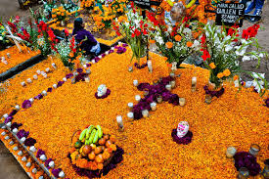
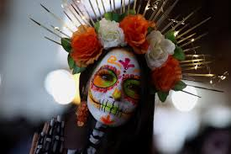
Mexican families set up a candlelit altar in their homes so the spirits of loved ones can find their way back to their relatives. The altar offers some of the favourite foods of the deceased—just in case they get hungry. Items that were important to the ancestors when they were alive, were placed on the altar to evoke memories; items consisted of favourite books or musical instruments.
To continue the celebrations, it’s off to the graveyard for a big party. Families bring a huge feast to eat while they clean tombstones, sing songs, and talk to their ancestors. Parents might even introduce a baby to a grandparent who died before the baby was born.
During Day of the Dead, life-size papier-mâché skeletons and miniature plastic or clay skeletons are everywhere. Mexicans honour their ancestors on Day of the Dead, but they're also reminding themselves that death is just a part of life. Hanging out with skeletons reminds people that one day they will be skeletons—but not for a very long time!
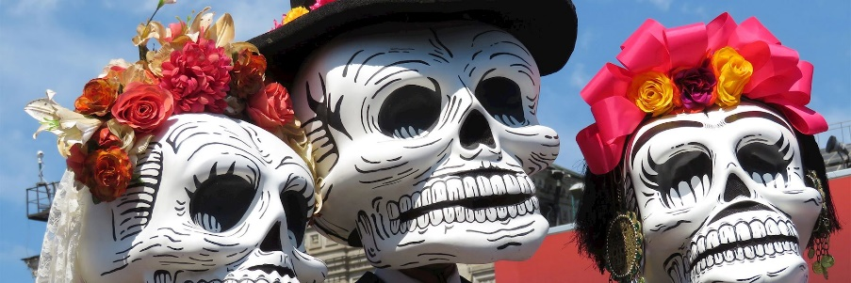
The skeletons are posed doing all sorts of wacky things, such as playing guitar, taking a bath, or making tortillas. Apparently, people aren't the only ones who get to have fun on Day of the Dead!

The Marigold flower was used to symbolise the brevity of life. The Marigold was used as an essential element of the Day of the Dead festival, these bright orange and yellow flowers’ fragrance is said to attract souls to the altar. Their bright and cheery colour also celebrate life instead of feeling bitter about death. Real or paper marigolds appear on altars, crosses, and garlands — and sometimes people even create a marigold path from their home to the altar.
https://kids.nationalgeographic.com/celebrations/article/day-of-the-dead
Questions:
- What is the Day of the Dead and when and where is it celebrated?
________________________________________________________________________________________________________________________________________________________________________________________________________________________________________________________________

- Name two things that families do to encourage their family members to visit them during the Day of the Dead.
________________________________________________________________________________________________________________________________________________________________________________________________________________________________________________________________

- Why is the Day of the Dead celebrated?
________________________________________________________________________________________________________________________________________________________________________________________________
- What do the skeleton decorations represent?
________________________________________________________________________________________________________________________________

- What are the main flowers used during the Day of the Dead festival and what do they represent?
________________________________________________________________________________________________________________________________________________________________________________________________

Week 5:
History
Why is the story of the Pendle Witches still well known today?
We have been studying the Stuart period of England and the different events that shaped life in this time, including the Gunpowder Plot, the English Civil War, and the Witches. This article focuses on one particular story of the Pendle Witches, in Lancashire.
Key vocab:
Notorious = well-known, but usually for a negative reason
Condemn = express complete disapproval of
Prosecute = charge (with a crime)
Scepticism = doubting
Doctrines = a belief or set of beliefs held and taught by a Church
--------------------------------------------
Reading:
Article: The Pendle Witches, taken from the Historic UK website.
Perhaps the most notorious witch trial of the 17th century, the legend of the Pendle witches is one of the many dark tales of imprisonment and execution at Lancaster Castle. Twelve people were accused of witchcraft; one died while held in custody, eleven went to trial. One person was tried and found guilty at York and the other ten were tried at Lancaster. Only one person was found not guilty. It was an unusual trial in that it was written about in an official publication, The Wonderfull Discoverie of Witches in the Countie of Lancaster, by the clerk of the court, Thomas Potts. As it was well-documented, the story has remained as a well-known legend. Also, just over three centuries saw witch trials held in England but fewer than 500 people were executed for this crime. This one series of trials in the summer of 1612 therefore accounts for 2% of all witches executed.
It is important to understand the background to the events of these trials. Six of the eleven “witches” on trial came from two rival families, the Demdike family and the Chattox family, both headed by old, poverty stricken widows, Elizabeth Southerns (aka “Old Demdike”) and Anne Whittle (“Mother Chattox”). Old Demdike had been known as a witch for fifty years; it was an accepted part of village life in the 16th century that there were village healers who practised magic and dealt in herbs and medicines. The extent of the outbreak of witchcraft reported in Pendle at this time perhaps reflected the large amounts of money people could make by posing as witches. Indeed, it was a time when witchcraft was not only feared but also fascinated those from common village folk to King James I. James I had been greatly interested in witchcraft even before he took the throne (in 1603), writing a book, Daemonologie, instructing his readers to condemn and prosecute both supporters and practitioners of witchcraft. This was the main reason that trials increased during his reign.
The king’s views were also imposed on the law; each Justice of the Peace in Lancashire at the beginning of the year of 1612 were instructed to compile a list of all those who refused to attend Church or take communion (a criminal offence).
The Pendle witch trials began with a quarrel between one of the people accused, Alizon Device, and a pedlar, John Law. Alizon, either travelling or begging on the road to Trawden Forest, passed John Law and asked him for some pins (it is not known whether her intention was to pay for them or whether she was begging). He refused and Alizon cursed him. It was a short while after this that John Law suffered a stroke, for which he blamed Alizon and her powers. When this incident was brought before Justice Nowell, Alizon confessed that she had told the Devil to lame John Law. It was upon further questioning that Alizon accused her grandmother, Old Demdike, and members of the Chattox family, of witchcraft. The accusations on the Chattox family seem to have been an act of revenge. The families had been feuding for years, perhaps since one of the Chattox family broke into Malkin Tower (the home of the Demdikes) and stole goods to the value of £1 (approximately the equivalent of £100 now).
The deaths of four other villagers that had occurred years before the trial were raised and the blame laid on witchcraft performed by Chattox. James Demdike confessed that Alizon had also cursed a local child some time before and Elizabeth, although more reserved in making accusations, confessed her mother had a mark on her body, supposedly where she had sucked her blood, which left her mad. On further questioning, both Old Demdike and Chattox confessed to selling their souls. Also Anne (Chattox’s daughter) was supposedly seen to create clay figures. After hearing this evidence, the judge detained Alizon, Anne, Old Demdike, and Old Chattox and waited for trial.
The story would have ended there had it not been for a meeting held at Malkin Tower by James Device (Alizon’s brother), for which he stole a neighbour’s sheep. Those sympathetic to the family attended, but word reached the judge who felt compelled to investigate. As a result, a further eight people were summoned for questioning and then trial.
The trials were held at Lancaster between 17th and 19th August 1612. Old Demdike never reached trial; the dark, dank dungeon in which they were imprisoned was too much for her to survive. Nine-year-old Jennet Device was a main supplier of evidence for the Pendle witches’ trial, which was allowed under the system from King James; all normal rules of evidence could be suspended for witch trials, as someone so young would not have been able to supply key evidence normally. Jennet gave evidence against those who attended the meeting at Malkin Tower but also against her mother, sister and brother! When she gave evidence against Elizabeth (her mother), Elizabeth had to be removed from the court screaming and cursing her daughter. Some of the Pendle witches seemed to be genuinely convinced of their guilt whereas others fought to clear their names. Alizon Device was one of those who believed in her own powers and was the only one on trial who was faced with one of their victims, John Law. When John entered the court, it is documented that Alizon fell to her knees, confessed, and burst into tears.
In conclusion, it seemed to be a range of exceptional circumstances that led to the extent of these witch trials. Indeed, Lancashire was exceptional in the number of witch trials that were held, in comparison to other regions who experienced the same degree of social depravity. The money that could be made from claiming powers in witchcraft in the 17th century probably caused the declarations made by the two families; they may have been in competition for the best reputation in the area. This backfired and the wild accusations escalated, fuelled by a general feeling of unrest and fear of witchcraft across the country, making this the biggest and most notorious witch trial.

Questions:
- Why was the trial of the Pendle Witches an “unusual trial”?
__________________________________________________________________________________________________________________________________________________________________________________________

- What is interesting about the background of those witches on trial?
__________________________________________________________________________________________________________________________________________________________________________________________

- What does the article suggest is one reason the number of witch trials increased during the reign of James I?
__________________________________________________________________________________________________________________________________________________________________________________________

- What was the incident that began this “witch” trial?
__________________________________________________________________________________________________________________________________________________________________________________________

- What did James allow as evidence that would normally not be allowed as evidence in a criminal trial?
__________________________________________________________________________________________________________________________________________________________________________________________

- Overall, what reasons does the article give for the two families starting the trial to begin with?
__________________________________________________________________________________________________________________________________________________________________________________________

Week 6:

Geography

The Rise of Extreme Tourism: Exploring the Edges of Adventure
Key vocab:
Monumental = very important
Treacherous = dangerous
Inhospitable = harsh and difficult to live in
Prestige = respect and admiration
--------------------------------

Reading:
What is Extreme Tourism?
Extreme tourism, also known as adventure tourism, involves travelling to dangerous or extreme locations and doing physically challenging activities. This type of tourism often requires a high level of fitness, mental toughness, and a willingness to face risks. The activities can range from climbing the world's highest peaks to diving with sharks, exploring war-torn regions, or going into extreme weather conditions.
Popular Extreme Tourism Destinations
- Mount Everest, Nepal: The highest peak in the world, Mount Everest, attracts hundreds of climbers each year despite the severe risks of altitude sickness, avalanches, and extreme weather. The idea of standing at the top of the world drives many to take on this monumental challenge.

- Antarctica: The coldest, driest, and windiest continent on Earth, Antarctica is a destination for those looking to experience one of the last frontiers. Visitors can try ice climbing, deep-sea diving, or even marathon running under some of the harshest conditions imaginable.
- Chernobyl Exclusion Zone, Ukraine: After the devastating nuclear disaster in 1986, the Chernobyl Exclusion Zone has become an eerie tourist destination. Visitors can explore the abandoned towns and experience the silence of a region still affected by radiation.
- Amazon Rainforest, South America: The dense and diverse Amazon rainforest offers extreme travellers a chance to navigate treacherous rivers, encounter dangerous wildlife, and survive in a challenging and unpredictable environment.
- Sahara Desert, Africa: The vast and scorching Sahara Desert is a magnet for those looking to test their limits. Activities include camel treks, sandboarding, and endurance races through one of the most inhospitable landscapes on Earth.


The Appeal of Extreme Tourism:
There are several reasons why extreme tourism is becoming more popular. Firstly, there is a growing desire among travellers to seek out unique and authentic experiences that go beyond the typical tourist activities. Extreme tourism provides a sense of achievement and a story worth telling. Additionally, the rise of social media has played a significant role, as travellers often want to share their extraordinary adventures with a wider audience, gaining social prestige and validation. Moreover, for many, extreme tourism offers a way to escape the ordinary and reconnect with nature. The physical and mental challenges associated with these adventures can lead to personal growth, self-discovery, and a great sense of accomplishment.

Risks and Ethical Considerations:

While extreme tourism can be very rewarding, it is not without significant risks. Participants can face life-threatening situations, and rescue operations in remote locations can be challenging and costly. There is also the ethical consideration of impacting fragile environments and local communities. Responsible tourism practices are essential to minimise the negative effects on both of these factors and to ensure that extreme tourism remains sustainable.

Preparing for Extreme Adventures
For those considering an extreme tourism adventure, thorough preparation is crucial. This includes:
- Physical Training: Building the necessary strength and endurance to handle the demands of the activity.
- Research and Planning: Understanding the risks, climate conditions, and necessary equipment for the journey.
- Travel Insurance: Ensuring comprehensive coverage that includes high-risk activities and emergency evacuation.
- Guidance from Experts: Engaging with experienced guides and tour operators who prioritise safety and have extensive knowledge of the destination.
Questions:

1. What does extreme tourism involve?
________________________________________________________________________________________________________________________________________________________________________________________________

2. Describe the attraction of two of the most popular extreme tourism destinations. (Why do people go? What can they do there?)
________________________________________________________________________________________________________________________________________________________________________________________________

3. How has social media played a significant role?
________________________________________________________________________________________________________________________________________________________________________________________________

4. Why is responsible tourism needed?
________________________________________________________________________________________________________________________________________________________________________________________________

5. What four things should people do to prepare before undertaking extreme tourism?
a. __________________________________________________
b. __________________________________________________
c. __________________________________________________
d. __________________________________________________

Week 7:

MFL

Free Time Activities in Spanish-Speaking Countries
Key vocab:
Deceased = dead
Intricate = complicated and detailed
--------------------------
Reading:
Free time activities, or "actividades de ocio," are an important part of life in Spanish-speaking countries. People enjoy a variety of pastimes, from sports and music, to festivals and outdoor adventures. Let's explore some popular free time activities in different Spanish-speaking countries.

Spain
In Spain, one of the most popular free time activities is enjoying tapas with friends. Tapas are small dishes that people share, and they are often enjoyed in tapas bars. Spaniards also love playing and watching football (soccer). Spain is home to some of the best football teams in the world, like FC Barcelona and Real Madrid. Another favourite activity is attending fiestas and festivals, such as La Tomatina, where people have a massive tomato fight.

Mexico

In Mexico, people enjoy a variety of traditional activities. One popular pastime is dancing to mariachi music, a lively genre that features guitars, trumpets, and violins. Mexicans also love celebrating festivals like Día de los Muertos, where families honour their deceased loved ones with colourful altars and festivities. Additionally, many Mexicans enjoy going to the beach, as Mexico has beautiful coastlines perfect for swimming and sunbathing.

Argentina
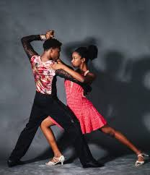
In Argentina, tango dancing is a beloved free time activity. Tango, which originated in Buenos Aires, is a passionate and intricate dance that people practice and perform in dance halls and on the streets. Argentinians also enjoy playing and watching football, with a strong passion for teams like Boca Juniors and River Plate. Another popular activity is visiting cafes and enjoying traditional foods like empanadas and mate, an herbal tea shared among friends.

Colombia
Colombians enjoy a wide range of free time activities, including dancing to the rhythm of cumbia and salsa music. These dances are energetic and often performed at parties and festivals. Colombians also love exploring the outdoors, from hiking in the Andes mountains to visiting the Amazon rainforest. Football is another favourite pastime, with fans passionately supporting their local teams.
Free time activities in Spanish-speaking countries are diverse and vibrant, reflecting the rich cultures and traditions of each nation. Whether it is dancing, enjoying delicious food, or celebrating colourful festivals, people in these countries know how to make the most of their leisure time. Learning about these activities helps us appreciate the unique ways people around the world relax and have fun.

Questions:
- What are tapas, and where are they popular?
________________________________________________________________________________________________________________________________________________________________________________________________

- Name two popular free time activities in Mexico.
- _______________________________________
- _______________________________________
- What dance originated in Buenos Aires, Argentina?
________________________________________________________________________________________________________________________________
- Which sport is widely loved and played in both Spain and Argentina?
________________________________________________________________________________________________________________________________________________________________________________________________

- Describe one traditional activity enjoyed in Colombia.
_________________________________________________________________________________________________________________________________________________________________________________________________________________________________
- How do Colombians enjoy the outdoors in their free time?
_________________________________________________________________________________________________________________________________________________________________________________________________________________________________

Week 8:
PE
Sky Brown – Britain’s youngest Olympic medallist

Britain’s youngest Olympic medallist Sky Brown competed in the Paris Games in 2024.
The 15-year-old skateboarder represented Team GB in the sport alongside 50-year-old Andy Macdonald and 16-year-old Lola Tambling in the Olympics in 2024.
Sky won a bronze Olympic medal when she was just 13 at Tokyo 2020. It was also the first time skateboarding was included at the competition.
"It was fantastic to witness skateboarding make its debut in Tokyo, and we were thrilled to see Sky make history as the youngest person ever to win a medal for Team GB at the Summer Games," Team GB chef de mission Mark England said.
Sky was also aiming to represent Britain in surfing at the 2024 Games, but missed out in qualifying.
Andy Macdonald has been skating professionally since 1994 and was the first British male skateboarder at an Olympic Games in 2024. 16-year-old Lola won the UK National Skateboarding Championship in 2022 and came sixth in the 2023 World Championship in Sharjah. The Olympic skateboarding events took place from 27th July to 7th August in Paris, 2024.

Questions:
- Sky Brown was how old when she first made an appearance at the Olympics?
______________________________________________________________________________________________________________________________________________________

- Who else represented Team GB in Paris 2024 Olympics, alongside Sky Brown?

- What medal did Sky Brown win at Tokyo 2020?

- What other Sport did Sky Brown hope to represent GB at the 2024 games?
______________________________________________________________________________________________________________________________________________________

- What did Mark England describe as ‘fantastic’ in his interview?
_________________________________________________________________________________________________________________________________________________________________________________________________________________________________

Week 9:
Technology
The History of the Tie-Dye Shirt
Key Vocab:
Heyday = a time of greatest success
Hippies = usually a young person who rejects established society and believes in peace; came to prominence in the 1960s
Era = a long and distinct period of history
Fluctuates = rises and falls irregularly
--------------------------
Reading:

If you think tie-dye originated in the 1960s, think again. While it rose to popularity in America during the heyday of the hippies, its roots go back to ancient Asia. While tie-dye became popular in the United States during the hippie era, it has actually been a part of American culture since the 1920s.
Tie-dye designs never really go out of style. While tie-dye’s popularity fluctuates, it is something that will be around for many years to come. Let’s take a closer look at the tie-dye shirt throughout history.
Tie-Dye in Ancient Asia
The earliest written records about tie-dye come from China and Japan. The process was used during the T’ang Dynasty in China and the Nara Period in Japan as far back as the 6th century. People used natural dyes from berries, leaves, roots, and flowers to colour clothing. These natural items were boiled, and the fabrics then soaked in the hot, dyed water to take on a new colour.
As early as the 6th century in India, people practiced a type of tie-dye known as Bandhani. This process involves using thread to tie off small pieces of fabric in intricate patterns before dipping the fabric in dye. This type of tie-dyeing is still practiced today.
In the United States, tie-dyeing first rose to popularity in the period known as the Roaring ’20s. It remained popular during the Great Depression as a way for people to cheaply decorate their homes and clothing using the tie-dyeing process.
The 1960s is, of course, the decade most commonly associated with tie-dye. While the style hadn’t been “in” for a few decades at that point, it saw an increase in popularity during the hippie era because it served as a simple and inexpensive way to express creativity. Hippies longed to escape from the strict societal norms of the 1950s, and tie-dye symbolises a free-spirited style.
When big stars like Janis Joplin and Jerry Garcia started wearing tie-dye, the youth of America quickly picked up on the trend. It became one of the most iconic looks of the time.
The 1980s and Beyond
While tie-dye shirts tend to come back in style every few years, they really hit a high point during the 1980s. During this decade, designers began incorporating this look into their fashion shows. The new types of dye that hit the market during the 1980s had much greater staying power, and they offered a greater variety of shades and colours.
Questions:
- When did tie-dye first become part of American Culture? _____________
- Where do the earliest records of tie-dye come from?
_______________________________________________________________________________________________________________________________________________________________________________________________________________________________________________________________

- What was the dynasty in China called, when this process was used?
________________________________________________________________________________________________________________________________________________________________________________________________

- During which century was tie-dye first used in Japan?
________________________________________________________________________________________________________________________________________________________________________________________________

- In the 6th century in India, what was the name given to the tie-dying process people practiced? What did this involve?
________________________________________________________________________________________________________________________________________________________________________________________________________________________________________________________________

- When was the most popular decade for tie-dye fabric?
________________________________________________________________________________________________________________________________________________________________________________________________________________________________________________________________

- Why did tie-dye become popular during this time?
________________________________________________________________________________________________________________________________________________________________________________________________________________________________________________________________________________________________________________________________
Week 10:

PSCHE
Dove pushes for legislation to protect kids’ self-esteem from social media

Key vocab:
Acute = severe or terrible
Disordered = irregular/not functional
Toxic = harmful
Systemic change = full overhaul of a system to create a lasting difference
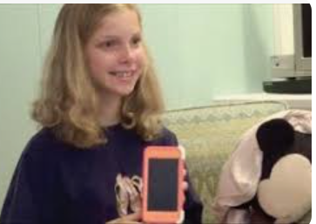
Reading:
The Dove Self-Esteem Project launched the ‘Campaign for Kids- Online Safety’ to address the rise in youth mental health issues linked to social media.

As part of the campaign Dove released a three-minute short film, “Cost of Beauty,” that tells the true story of a young person whose mental health has been affected by social media.

The campaign is informed by new Dove research that demonstrates the toll social media has on youth mental health, with eight in 10 specialists saying social media is fuelling a mental health crisis. Not only do 80% of young people believe people their age are addicted to social media, but more than half say it makes them and their peers feel anxious.

The problem is particularly acute around how social media affects body image issues and related behaviours. Seven in 10 people ages 10-17 have been exposed to social media content that encourages weight loss or body transformation, with more than half of people ages 14-17 exposed to content that encourages restricted eating or disordered eating behaviours.

While certain aspects of social media can promote creativity and connection for young people, data has shown toxic content online is harming the mental health of today’s youth. “If there isn’t real change, young people will continue to pay with their wellbeing,” said Dove CMO Alessandro Manfredi in the press release. “We have a responsibility to act and support a safer environment on social media, helping protect young people’s mental health. This means going beyond individual interventions to drive systemic change.”

Questions:
1. Why have Dove launched the ‘Campaign for Kids’ project?
________________________________________________________________________________________________________________________________________________________________________________________________________________________________________________________________

2. Find a statistic in the text which shows that social media can be damaging to the mental health of young people and write this below.
________________________________________________________________________________________________________________________________________________________________________________________________

3. What is Alessandro Manfrendi’s opinion on what action should be taken?
_________________________________________________________________________________________________________________________________________________________________________________________________________________________________

